AREA CODE - Opportunity Area |  |  |  |  |  | 
Insert map of the opportunity area |  |  | Insert ariel photo of the area |  |  | Total properties:  Total no.
A short description of the area and the housing stock |  |  |  |  |  | Listed buildings:  Total no.
Tenure  Detail on any key stakeholders who may aid delivery. I.e. social housing providers or community groups |  | Insert photo of the area, showing the most prevalent housing stock may be beneficial. |  |  |  | Near coastline:  yes/no
Anchor load?
yes/no
Available funding  Any relevant government funding. |  |  |  |  |  | Anchor load?  yes/no
Average garden size
Size m2
Attachment  End terrace:no.  Mid terrace:no.  Semi-detached:no.  Detached:no.  Unknown:no. |  | Tenure  Private rented:no.  Social rented:no.  Owner occupier:no.  Unknown:no. |  |  |  | EPC  A:no.  B:no.  C:no.  D:no.  E:no.  F:no.  G:no.  Unknown:no.

AREA CODE - Opportunity Area |  |  |  |  |  | 
Insert map of the opportunity area |  |  | Insert ariel photo of the area |  |  | Total properties:  Total no.
A short description of the area and the housing stock |  |  |  |  |  | Listed buildings:  Total no.
Tenure  Detail on any key stakeholders who may aid delivery. I.e. social housing providers or community groups |  | Insert photo of the area, showing the most prevalent housing stock may be beneficial. |  |  |  | Near coastline:  yes/no
Anchor load?
yes/no
Available funding  Any relevant government funding. |  |  |  |  |  | Anchor load?  yes/no
Average garden size
Size m2
Attachment  End terrace:no.  Mid terrace:no.  Semi-detached:no.  Detached:no.  Unknown:no. |  | Tenure  Private rented:no.  Social rented:no.  Owner occupier:no.  Unknown:no. |  |  |  | EPC  A:no.  B:no.  C:no.  D:no.  E:no.  F:no.  G:no.  Unknown:no.

AREA CODE - Opportunity Area |  |  |  |  |  | 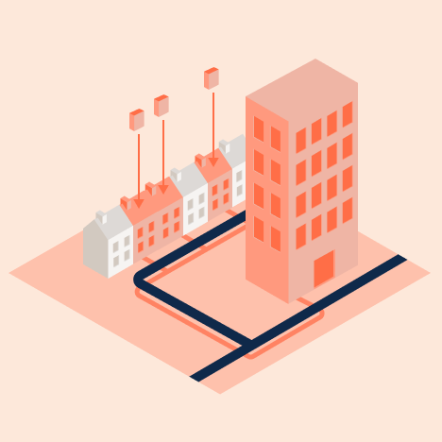
Insert map of the opportunity area |  |  | Insert aerial photo of the area |  |  | Total properties:  Total no.
A short description of the area and the housing stock |  |  |  |  |  | Listed buildings:  Total no.
Tenure  Detail on any key stakeholders who may aid delivery. I.e. social housing providers or community groups |  | Insert photo of the area, showing the most prevalent housing stock may be beneficial. |  |  |  | Near coastline:  yes/no
Anchor load?
yes/no
Available funding  Any relevant government funding. |  |  |  |  |  | Anchor load?  yes/no
Average garden size
Size m2
Attachment  End terrace:no.  Mid terrace:no.  Semi-detached:no.  Detached:no.  Unknown:no. |  | Tenure  Private rented:no.  Social rented:no.  Owner occupier:no.  Unknown:no. |  |  |  | EPC  A:no.  B:no.  C:no.  D:no.  E:no.  F:no.  G:no.  Unknown:no.

